Project design phase
Problem -solution fit Template
Date | 1November2025
Team ID | NM2025TMID02619
Project Name | Calculating family Expenses using service now
Maximum Marks | 2Marks

Problem–Solution Fit Explanation
The Problem–Solution Fit identifies how effectively the proposed Family Expense Calculation System addresses real-world challenges faced by families in tracking, organizing, and managing financial data. By implementing this system in ServiceNow, users can automate expense tracking, minimize manual errors, and gain insights into their spending patterns through analytical dashboards.

Purpose
☑ Simplify daily expense management for families through a centralized, automated platform.
☑ Increase financial awareness by providing visual insights and monthly spending summaries.
☑ Reduce manual work and prevent calculation or categorization errors.
☑ Enable data-driven decision-making through real-time reports and dashboards.
☑ Provide transparency and shared access among all family members securely.

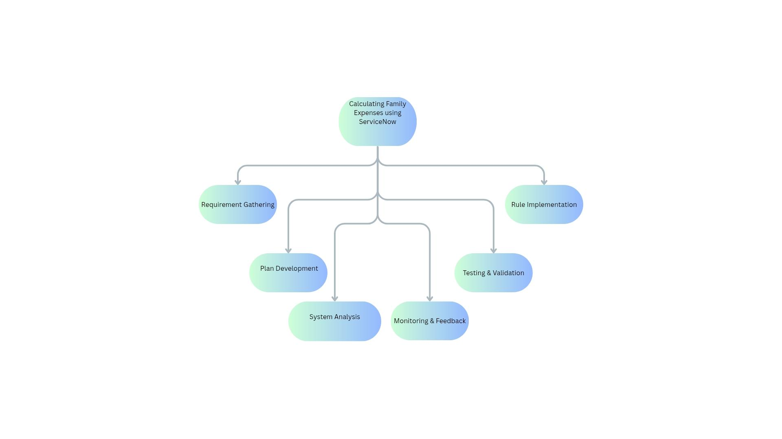

Reference: https://www.canva.com/design/DAG3npX9o6U/PtQZQ06kWSjtb42HlZCoCw/edit?utm_content=DAG3npX9o6U&utm_campaign=designshare&utm_medium=link2&utm_source=sharebutton
The project "Calculating Family Expenses using ServiceNow" addresses a vital need for efficient and organized financial management within households. By enabling users to record, categorize, and analyze their daily expenses through the ServiceNow platform, this system eliminates the difficulties of manual tracking and reduces calculation errors. The solution ensures accuracy, transparency, and accessibility for all family members while promoting better budgeting habits.
Through automation, families can easily monitor their spending patterns, receive budget alerts, and generate insightful monthly or yearly reports. This not only simplifies financial planning but also enhances awareness of saving opportunities and expenditure control.
With the successful implementation of ServiceNow workflows, business rules, and dashboards, the project delivers a reliable, scalable, and user-friendly expense management system. Ultimately, this solution lays a strong foundation for smarter financial decision-making, empowering families to maintain stability, accountability, and long-term financial well-being.

